1. Capture and analyze ARP packets using Wireshark. Inspect the ARP request and reply frames, and discuss the role of the sender's IP and MAC address in these packets.
- Open terminal and start Wireshark:
sudo wireshark
- Select the active network interface:
eth0 or wlan0
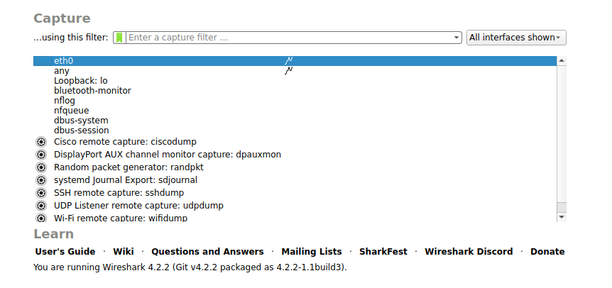

- Click on Start Capture (Shark fin icon)
- Open a new terminal window.
- Generate traffic using:
ping 8.8.8.8
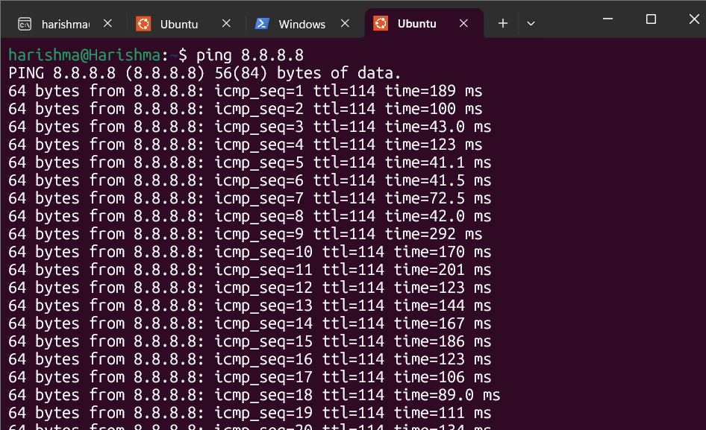
- Go to Wireshark and apply filter:
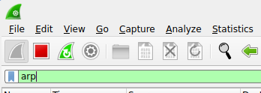
- Observe ARP request and reply packets.
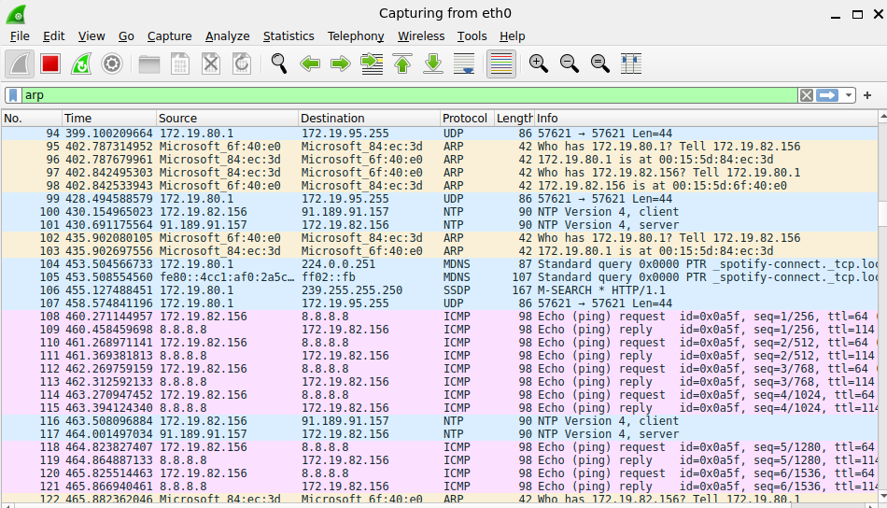
- Stop the capture after few seconds.
2. Using Packet Tracer, simulate an ARP spoofing attack. Analyze the behavior of devices on the network when they receive a malicious ARP response.

